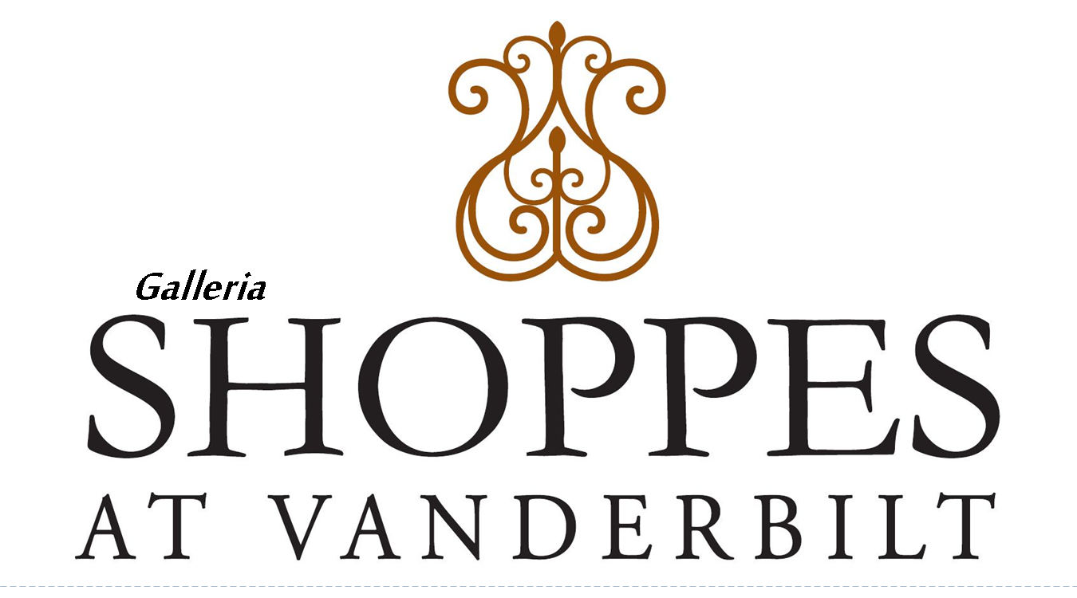
Existing Tenant Improvement Request Form
As Owner of the business named below, I request approval to install, at my expense, one or more of the following types of alterations with the understanding that the installations will be in conformance with current specifications (as applicable), special instructions and/or comments listed below. Any contractor I hire to perform the approved alterations will be licensed and insured, and will obtain any permits which may be required by all applicable governmental bodies. Under no circumstances shall I allow any construction to take place without following the required protocol.
Owner Name(s): ___________________________________
Unit #: ________________
Phone #: ________________ Cell: ______________
Date: _________________
ARCHITECTS PLANS & DRAWINGS MUST BE ATTACHED BEFORE APPLICATION WILL BE CONSIDERED. COPIES OF CONTRACTORS’ CURRENT CERTIFICATE OF INSURANCE AND LICENSE, AND BUILDING PERMITS FROM COLLIER COUNTY MUST BE ATTACHED BEFORE FINAL APPROVAL FROM THE SHOPPES AT VANDERBILT.
I herby make application to The Shoppes at Vanderbilt for the above described item to be approved in writing.
I understand and acknowledge that approval of this request must be granted before work on the modification may commence and if modification / installation is done without the approval of the Association; the Association may force the removal of the modification/ installation and subsequent restoration to original form at my expense.
___________________________________ _________________
Applicant Signature Date

This Section for Office Use Only
Application Approved_____ Application Denied_____
X _______________________________ _______________________
Management Signature Date

